Magic Invitational Report: Dave Price
David Price
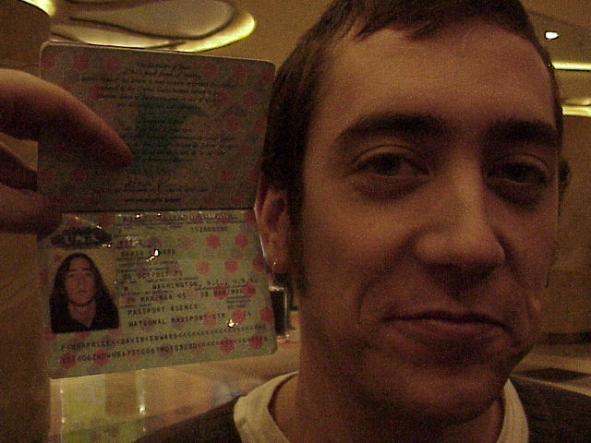
Ah, the Magic Invitational... I've attended three, so far, getting the opportunity to travel to Barcelona, Spain, Kuala Lumpur, Malaysia, and now Sydney, Australia to compete against 15 fierce Magic competitors for the right to design a card for a future expansion set. In my first Invitational in Barcelona I finished in 6th place, while I struggled in Kuala Lumpur, Malaysia and ended up with a 12th place finish. I had hopes of winning this Invitational, as I had two good Constructed decks and as good a chance as any to figure out Mark Rosewater's Duplicate Limited and Solomon Draft in time.

I was ready for Vintage...
While I love the competition that comes with playing in Pro Tour Qualifiers, Grand Prix, and Pro Tours, I don't get a thrill out of some of the other aspects of the game that other Magic fans do. For instance, I don't really follow the Magic storyline, but I discovered during my work as editor of the Dojo in which we ran a short story contest set in the Magic universe that many other Magic players are fans of the storyline. In much the same way, while I feel that I might have some insight into what makes a balanced card after playing years of competitive Magic, I know that others get a far greater thrill out of designing potential Magic cards than I do, going so far as to create their own expansions, so once again, I asked my readers at StarCityGames.com to send me their beatdown cards.
I received many great submissions, but finally decided on a card sent to me by Brett Reid:
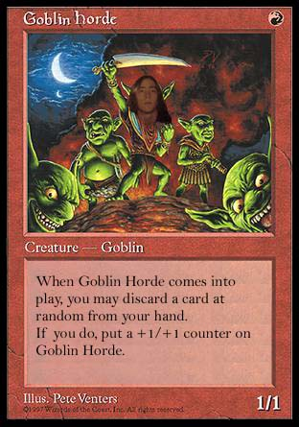
Goblin Horde
R
Creature - Goblin
1/1
When Goblin Horde comes into play, you may discard a card at random from your hand. If you do, put a +1/+1 counter on Goblin Horde.
Not the most glamorous of cards, it was my best shot at getting a two power creature for one mana made by Wizards of the Coast R&D. If anything, this card was a bit underpowered and it would need some fine tuning, but I liked the idea behind it and overall, the mechanic and the card seemed balanced.
So what next? I had a card to submit to Mark Rosewater and two Constructed decks for the tournament, so I hopped on a plane bound for Sydney, Australia. The way scheduling worked out, I had to leave the United States by Sunday which prevented me from playing in Grand Prix - Phoenix anyhow, so I requested that I get flown out a few days early so that I could take a side trip to Melbourne and get a brief view of a different part of Australia. Fortunately, the short plane trip from Sydney to Melbourne was inexpensive and I'd met a few people who lived in Melbourne while backpacking around Europe after I finished university, so I had a place to stay and some old faces to see as well.
All in all, I had a good time in Melbourne, which turned out to be a bit more laid back than Sydney, with lots of sidewalk cafes and the like. I got to see the beach and a few of the sights and then I was off to Sydney for the Invitational.
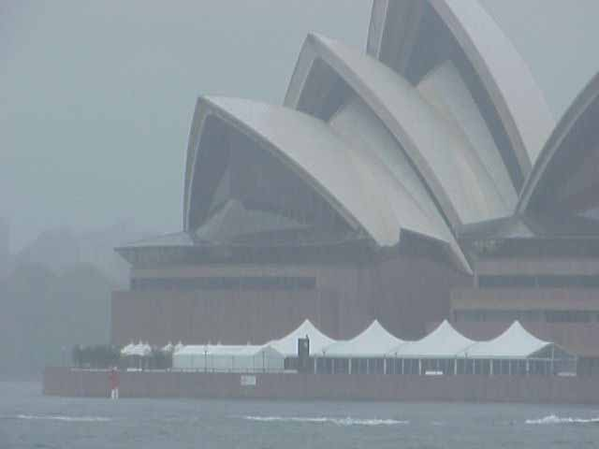
What to say about Sydney? It rained the whole time we were there, so I didn't get the best impression of it, I'm afraid. The tour of the city involved us being driven around in a bus and then stopping under a bridge (which didn't shield us from the rain, mind you), where we got to stand outside and have our picture taken with the Opera House as the backdrop. It was a great idea, as long as it wasn't raining cats and dogs, but as it turned out, it was a miserable morning.
On the other hand, the hotel was extremely nice, being connected to a casino and having dozens of restaurants and shops connected to it. I steered clear of the casino as I didn't want my "free trip" to Sydney to cost me much more than necessary, but I do believe I put on a few pounds, especially at this one Italian restaurant near the top with a fantastic view of the city.
What, did you want to hear about the tournament?

Duplicate Sealed
The first format was one of Rosewater's favorites, Duplicate Limited. He gives each competitor the same selection of cards and they try to build decks to beat each other. This wouldn't be so bad, except that Mark likes to mix things up, giving us cards that we haven't seen before (like last year) or in the case of this year, giving us cards with different casting costs. Each card was like a card that we know, except the casting cost was different, meaning that we had to reevaluate them.
I made one key mistake while deckbuilding and that was overvaluing Survival of the Fittest. The other color that I chose was white, because it had enchantment and artifact destruction, creature elimination (a five casting cost Swords to Plowshares) and efficient creatures. I figured my mistake out very quickly, sideboarding into a full-fledged green/white beatdown deck with Revered Unicorn and Wild Mammoth as the all-stars every second game. I ended up going 2-1, mostly due to my sideboarding, beating Zvi Mowshowitz and Kai Budde and losing to Ryan Fuller. The match against Zvi was written up by the Sideboard as a feature match and can be found here for those interested.

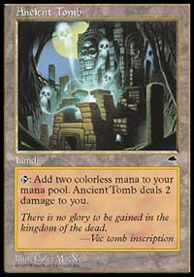
BYOB (Bring Your Own Block)
I had originally intended to play a straightforward red beatdown/burn deck in the BYOB format, but I was having trouble creating a version that I really liked. When Chris Pikula showed me a Red deck using Ancient Tombs for quick land destruction like Stone Rain and Avalanche Riders, a very similar deck to the Standard deck that we played in the 1999 World Championships in Tokyo, Japan, I fell in love. All the spells in the deck were good and with 3 main deck Balduvian Hordes and a fourth in the sideboard, it appeared it would have an advantage against other red decks, as well.

David Price
Ancient Tomb Red TE-UY-AL
Main Deck |  | Sideboard
4 Jackal Pup  4 Mogg Fanatic  4 Fireslinger  4 Avalanche Riders  3 Balduvian Hordes  4 Stone Rain | 4 Pillage  4 Kindle  4 Parch  4 Wasteland  4 Ancient Tomb  17 Mountain | 4 Bottle Gnomes  4 Boil  4 Burnout  3 Pyrokinesis  1 Balduvian Hordes
The primary distinction between my version and the versions that the other players played in the BYOB portion of the tournament (including the copy that Chris Pikula gave to Ryan Fuller) was my lack of Ghitu Encampments. I felt that have a these Wasteland targets would really hurt me in the mirror match and it could also cripple me against other decks with Wastelands since I expected many of the competitors to play with Tempest as their primary set. With the matchups that I got, I was happy with my decision.
I successfully avoided all of the red hate the other decks had in their sideboards (COP: Red, Chill, etc.) by playing against another Ancient Tomb Red deck, a Speed Red deck, and a Red/Green Fires of Yavimaya deck. I ended up going 3-0 in the format, beating Noah Boeken playing Speed Red, Trevor Blackwell playing Ancient Tomb Red, and Yoshikazu Ishii playing Green/Red Fires.

Solomon Draft
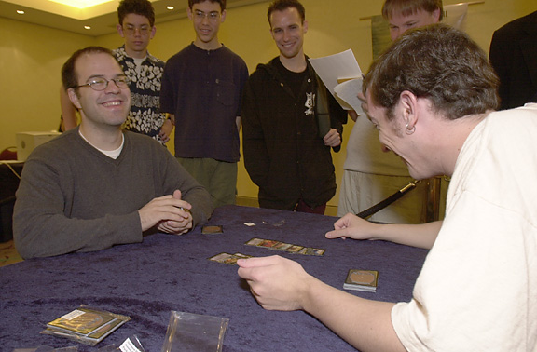
Bitter rivals?
I specifically requested that I get paired up against Mike Long in a Constructed format, which I felt was my strong point (as opposed to the wacky Rosewater Limited formats), but Mark Rosewater mumbled something about "random" pairings and before I knew it, I was sitting down across from Mike Long in Solomon Draft. This particular Solomon Draft was bound to give me trouble as well, as I'm a well-known proponent of mono-color decks and basic lands; the draft was full of all gold cards, multi-lands and cameos! I don't want to dwell on this match, especially since you can read all about it on the Sideboard here and here. To keep things short, my mana sucked and Mike Long cast Meteor Storm on the second turn of each game, which proved to be an incredibly broken card in this format.
My next two drafts went a great deal better however, as I threw caution to the wind and chose to ignore whatever clever thing Rosewater was attempting to do in the drafts. Instead of drafting whatever combos were built into the draft, I decided to just draft beatdown in the next two formats. Against Finkel in the Legendary Solomon Draft, I gave him both the protection from Legends, tap to destroy a Legend creature (Tsabo Tavoc) and Empress Galina, which could tap to gain control of a Legend. Instead, I drafted efficient beatdown legends and powerful spellshapers like Jolrael, Empress of Beasts and I added with that Fervor and Sword of the Chosen and a few removal spells and attacked, attacked, attacked. Against Chris Pikula, he ended up with all sorts of combos like Whim of Volrath/Light of Day and a number of other tricky tricks. I cast creatures (including the dreaded Kavu Chameleon) and beat him down, barely squeaking out my third game against him. You can read about my match against Finkel here and against Pikula here. I ended up beating both of the them, going 2-1 in the Solomon Draft format.

Auction of Champions
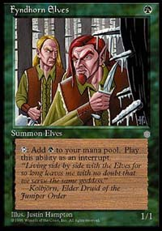
I had a great shot at the finals going into this format, although I had no idea what I wanted to play in it. Of course, I wanted to play my deck from PT-LA '98, but from what I heard from the other players, I was going to have to pay out the nose for it, as others felt that it was very good in this environment. In the end, I let Ben Rubin have it for 7 cards and 13 life and I picked up Brian Selden's Recur/Survival deck for 7 cards and 14 life. Unfortunately, luck wasn't going to hold with me this format. I got matched up against Bob Maher playing Loconto's deck, which featured Disenchant (for Survival of the Fittest), Control Magic, countermagic (for Recurring Nightmare), Swords to Plowshares, Wrath of God, and Balance. Not a good matchup for me. It was close and I kept a questionable mana draw in the third game and was punished for it by Bob when he Control Magic'd my Bird of Paradise on the third turn (by sacrificing a Svyelunite Temple). In my next match, I was paired against Darwin Kastle playing Olle Rade's deck, which is only any good if it gets a first turn Fyndhorn Elf (as it is notoriously low on mana). Naturally, Darwin played a first turn Fyndhorn Elf in each game and bashed me in the face. My final matchup was against Gary Wise who paid a bit too much for Randy Buehler's Necro deck and paid the price, going 0-3 and losing to me in the last round, giving me a 1-2 record in the Auction of Champions. I needed to go 2-1 or 3-0 in the Vintage portion to have a shot at the finals.

Vintage
Fortunately, I was ready for Vintage. I came prepared with my Workshop deck from last year, that was originally sent to me by Andrew Cuneo in response to one of my articles. I had been playing and tuning the deck for some time and I was confident that it was a very good Vintage deck. My only problem was that it was easy to sideboard against and everyone would know who his last three opponents were by the time Vintage rolled around. So I needed to convince the other players that I couldn't possibly play this deck for that very reason, so that they wouldn't pack a million extra Disenchants and Divine Offerings in the sideboard of their decks.
It worked. I wasn't overly sideboarded against and since I'd figured out that two of my three opponents were playing heavy red, I could heavily sideboard against them. The unknown opponent was Alex Shvartsman, who had a tendency to play red anyhow, so I felt comfortable loading my sideboard to beat them. I couldn't justify screwing with the main deck, however, as I still wanted to have a shot if I made it to the finals.
David Price
Main Deck |  | Sideboard
1 Black Lotus  1 Mox Sapphire  1 Mox Jet  1 Mox Ruby  1 Mox Pearl  1 Mox Emerald  1 Sol Ring  1 Strip Mine  1 Tolarian Academy  4 Wasteland  4 Mishra's Workshop  4 Underground Sea  2 City of Brass  4 Underground River  1 Stroke of Genius  1 Ancestral Recall  1 Timetwister  1 Time Walk | 1 Tinker  1 Demonic Tutor  1 Demonic Consultation  1 Yawgmoth's Will  1 Mind Twist  1 Vampiric Tutor  1 Memory Jar  1 Karn, Silver Golem  1 Icy Manipulator  4 Juggernaut  4 Su-Chi  4 Mana Drain  4 Force of Will  4 Duress | 4 Hydroblast  3 Blue Elemental Blast  4 Bottle Gnomes  1 Triskelion  2 Misdirection  1 The Abyss
My matches against Ben Rubin and Alex Shvartsman were covered by the Sideboard here and here. My match against Gerard Godinez Estrada went as planned, with me losing the first game and winning the second two games with my insane anti-red sideboard. In the coverage on the Sideboard of my loss against Ben Rubin, the writer discusses the key mistake that I made against Ben Rubin. My mistake stems from the fact that I don't know what was in Ben Rubin's hand and I didn't know whether he was playing off color power cards like Balance or even sideboard cards like enchantment or artifact destruction. In the case of Ben Rubin playing off-color cards, it becomes increasingly dangerous to sit back on my Hydroblast and give him an extra turn to draw the non-red answer or the mana that he needs to cast the answer. As it turns out, I made a poor decision and lost because of it. Such is life. I did, however, beat Alex Shvartsman and ended up going 2-1 in Vintage.
This gave me a 10-5 record overall and I lost to Ben Rubin on tiebreaks to come in 3rd place, missing out on the finals.
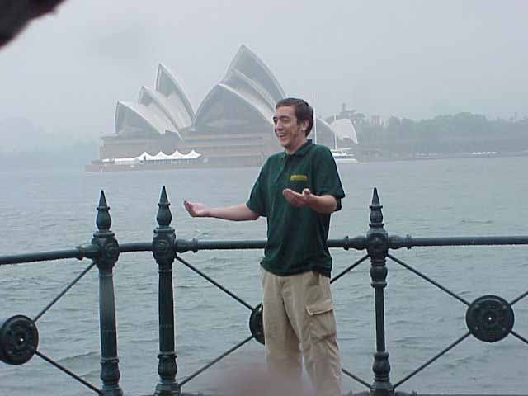
I'll get 'em next time. With the help of the readers and Magic players out there, I'd love to attend the Invitational again next year and try again to get one of your card designs turned from an idea into reality.
All in all, I had a great time at the Invitational. I still love playing the game and I'm looking forward to another year on the Pro Tour and Grand Prix circuit.
David Price
King of Beatdown
dep6@ix.netcom.com

